**Database Analyst**

**5CS024 - 2110047**

**Data Modeler and Tracker**

Data Modeler 1

Phpmyadmin and code: 1

Cuslog 2

Carerlog 2

CustomerPosts 2

CarerPostsViews 3

Analysis 4

# Data Modeler

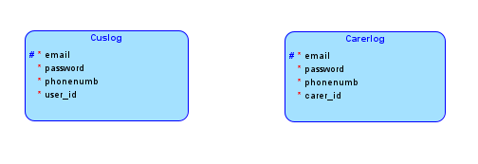

Currently there is not a large amount of data being passed around or stored as this is the basis for the website, there is also not a direct link between the tables as there are no foreign keys between them.

# Phpmyadmin and code:

## Cuslog

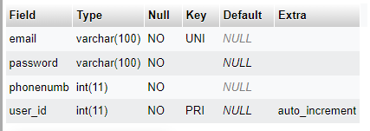

CREATE TABLE `Cuslog` (

`email` varchar(100) NOT NULL,

`password` varchar(100) NOT NULL,

`phonenumb` int(11) NOT NULL,

`user_id` int(11) NOT NULL AUTO_INCREMENT,

PRIMARY KEY (`user_id`),

UNIQUE KEY `email` (`email`)

) ENGINE=InnoDB DEFAULT CHARSET=latin1

## Carerlog

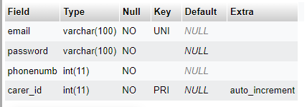

CREATE TABLE `Carerlog` (

`email` varchar(100) NOT NULL,

`password` varchar(100) NOT NULL,

`phonenumb` int(11) NOT NULL,

`carer_id` int(11) NOT NULL AUTO_INCREMENT,

PRIMARY KEY (`carer_id`),

UNIQUE KEY `email` (`email`)

) ENGINE=InnoDB DEFAULT CHARSET=latin1

## CustomerPosts

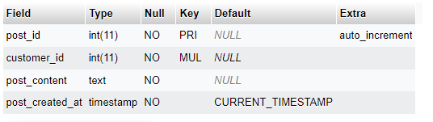

CREATE TABLE `CustomerPosts` (

`post_id` int(11) NOT NULL AUTO_INCREMENT,

`customer_id` int(11) NOT NULL,

`post_content` text NOT NULL,

`post_created_at` timestamp NOT NULL DEFAULT current_timestamp(),

PRIMARY KEY (`post_id`),

FOREIGN KEY (`customer_id`) REFERENCES `Cuslog`(`user_id`)

) ENGINE=InnoDB DEFAULT CHARSET=latin1;

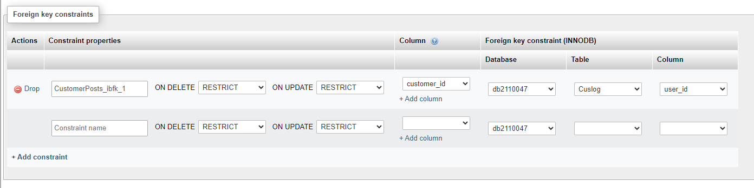This is showing the foreign key links to another table

## CarerPostsViews

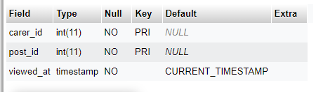

CREATE TABLE `CarerPostViews` (

`carer_id` int(11) NOT NULL,

`post_id` int(11) NOT NULL,

`viewed_at` timestamp NOT NULL DEFAULT current_timestamp(),

PRIMARY KEY (`carer_id`, `post_id`),

FOREIGN KEY (`carer_id`) REFERENCES `Carerlog`(`carer_id`),

FOREIGN KEY (`post_id`) REFERENCES `CustomerPosts`(`post_id`)

) ENGINE=InnoDB DEFAULT CHARSET=latin1;

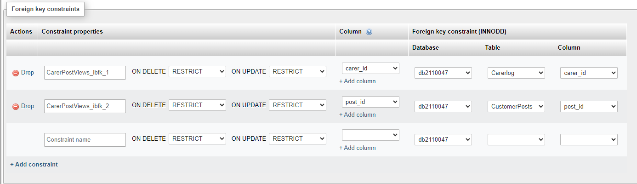

This is showing the foreign key links to another table

# Analysis

The main objective of this database is to implement a simple structure of the database in order for the customer and the carer to be able to log in and share information between one another. The customer will be able to log in, set up a post which indicates they are searching for a carer and for them to then be able to communicate with the carer. The carer has a similar structure: they can login, view active posts made by customers, and select which posts they are able to fulfil and then also communicate between themselves and the customer. All this information would be stored on Phpmyadmin and stored on the university server, Mi-linux. At the early stage of the development there is not much security for the databases as they are mainly being used for testing and ensuring that the whole database works, but later there would be a form of security such as re-naming the tables to something more secretive to prevent SQL injections. There would be a decent amount of information passed around on this database and it's important to ensure that the database is correctly setup, such as with primary keys and foreign keys linking to parent tables which are crucial to the integrity of the database, security and efficiency of the website itself. Later on in the databases life there would be an implementation of other tables and a higher flow of information, such as a reviews section for the customers to be able to use for other customers to be able to view which carers are the best and this would also have to be securely created in order to ensure the safety of information. Furthermore, it's important to prevent data redundancy in order to keep the server running smoothly, which in turn helps the website run smoothly, and this is why primary and foreign keys are being used in order to ensure that only the important information is shared between tables, such as the IDs of carers and customers.